**Go Paddle**

**Program**

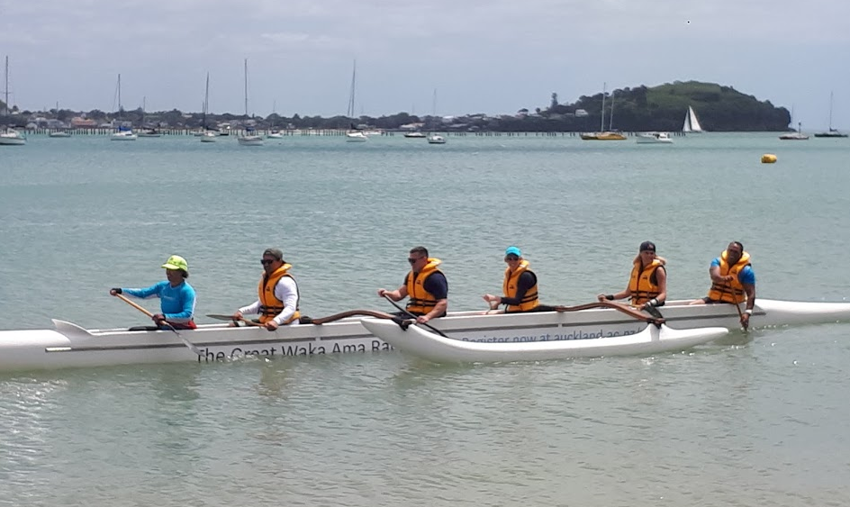



**Paddle Program**





Notes

If you are struggling with your rotation, think about pushing your chest forward and your shoulders back as if you were standing smartly to attention. This will link your stroke to your core much better and help you to drive your rotation

Visualisation

Imagine someone is going to punch you in the stomach, now twist your core to avoid being hit

**Land Training**



1. Squat Jumps 2. Push Ups 3. Standing Abs

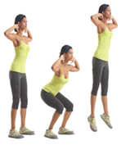 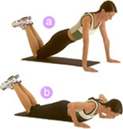 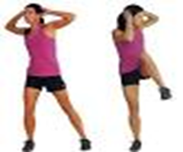

4. Mountain Climbers 5. Burpee

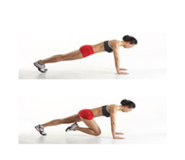 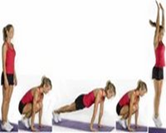

**Stroke Technique**

**Phase 1 Set Up**

Reach by twisting forward and aiming your paddle to the point where you are going to put your blade into the water – needs to have a forward angle

**Phase 2 Catch**

Enter with a forward angle and set the blade under the water

**Phase 3 Pull/Power**

Lock the paddle in the water and push off your feet & legs and work your way up the body to drive the canoe forward towards the paddle

**Phase 4 Exit**

Exit the water when your fist reaches your hip by engaging the top hand

**Phase 5 Recovery**

Twist the torso to get the body and blade forward, paddle skims the top of the water, ready for the set up

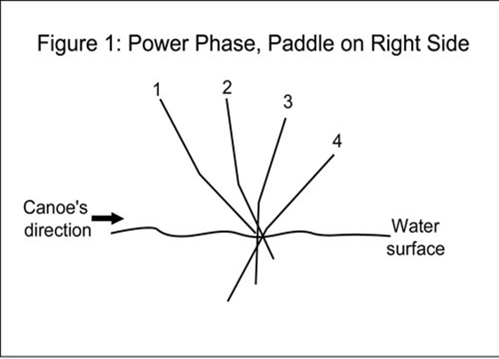

**Core Work**

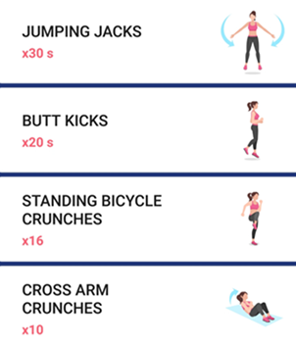 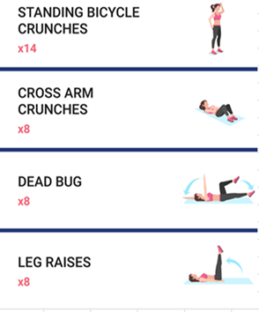

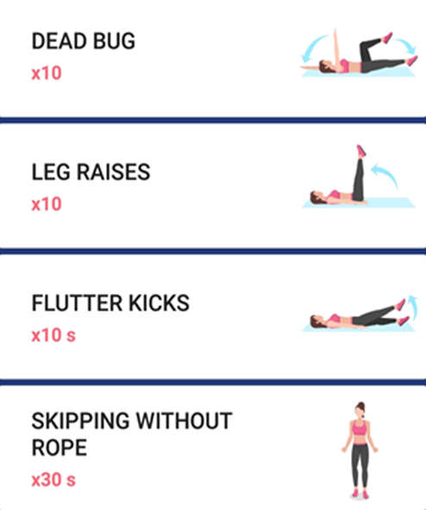 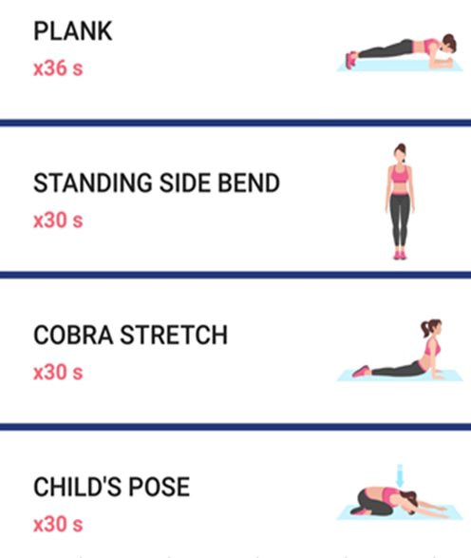

**Safety**

**Roles and responsibilities**

The following are minimum requirements for skippers and paddlers

Please remember that the skipper (kaihäutu) is legally responsible if there is an incident. Unless otherwise designated, the steerer is considered to be the skipper.

**The Skipper or Kaihäutu must:**

* have read and understand the Waka Ama Safety Rules
* understand what can happen with local weather conditions
* check that each paddler has a PFD on board that fits them and decide
* log a trip report
* know all the crew’s capabilities for paddling and swimming, and their medical needs

**The Paddler or Kaihoe must:**

* be competent in safety procedures for swamping, capsizing and paddler-overboard situations
* be familiar with the use of flotation devices, close at hand and on a support vessel
* be able to swim at least 50m, and if they can’t, wear a PFD at all times and inform the other paddlers that they are non-swimmers
* must not be under the influence of drugs or alcohol while on the water
* advise of any injuries
* be competent to cope with any situation.

**Swamping**

* Do not move from your position.
* Hold your hoe in tapäpa position (horizontal across the gunwales).
* Do not lean or shift weight.
* Wait and listen for the kaihäutu's commands.

**Capsize or rolling**

* Do not let go of your hoe.
* Take hold of the waka and use it for extra buoyancy.
* Check to see where your partner is and whether he or she needs help.
* Use hoe to help others reach the waka.
* Carry out a roll call.
*  Initiate roll or capsize procedures.

**Man overboard**

All waka crew must be trained in how to use the rescue tube and throw bag.

Ref: <https://www.wakaama.co.nz/content/page/3/attachments/Waka-Ama-safety-rules.pdf>

**Safety**

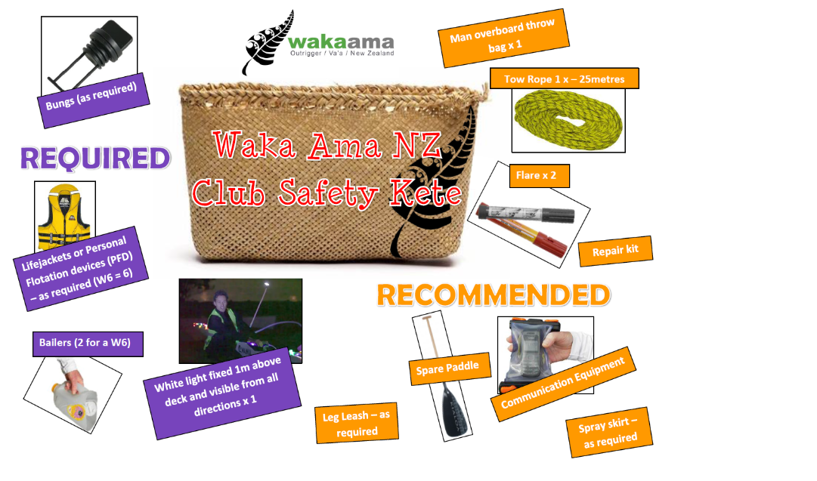

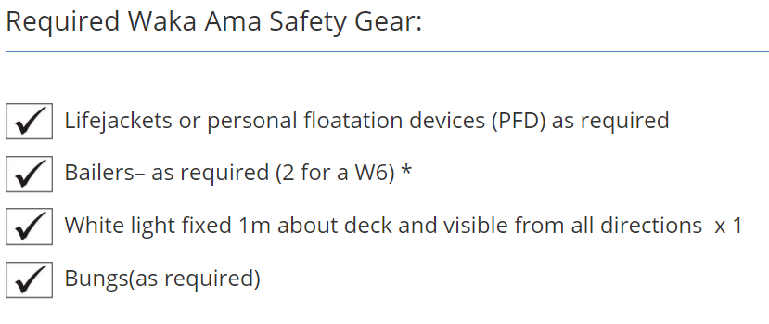

**Notes**

Contact: Tania Albert

Phone 021-0833-6804

**Email**

Oceanbluesports@gmail.com

**Website**

<http://www.oceanbluesports.com/>

To find out more ablout Waka Ama

Also view - <https://www.wakaama.co.nz/>